**Background:** People make choices every day. They choose products like orange juice or a car, decide who to vote for, and choose how to get to work. Marketers, retailers, product designers, political scientists, transportation planners, sociologists, and many others want to understand what drives these choices. Choice models predict what people will choose as a function of the features of the options available and can be used to make important product design decisions. This course will teach you how to organize choice data, estimate choice models in R and present findings. This course covers both analyses of observed real-world choices and the survey-based approach called conjoint analysis.

Regression modelling relates predictors to numeric outcomes?

A **linear regression model** is used to predict a **number**.

In marketing, we might use a **linear regression** to understand how how the sales at a store are related to the features of that store. Sales is a number.

Many events we want to understand and predict are choices.

• selecting a dress for a special occasion from an online retailer

• choosing what to watch on a video streaming service

• Buying a car.

Choices require their own special type of regression

**Multinomial logistic regression** or the **multinomial logit model** is used to predict a choice from a set of alternatives. The prediction is based on the features of each alternative. For instance, we can predict the likelihood of choosing a particular car based on the features of the available cars.

**Logistic regression** or the **logit model** is a special case of multinomial logistic regression used to predict binary "yes/no" such as the uptake on a promotional offer.

**Applications Of choice models:**

Marketing applications for choice models.

Designing new products

* Understand how product features relate to what people will buy

Pricing

* Determine how price is related to market share

Merchandising

* Measure the effect of a "customer favorite" flag on which product an online shopper chooses

**Inspecting Choice data:**

**Data challenges:**

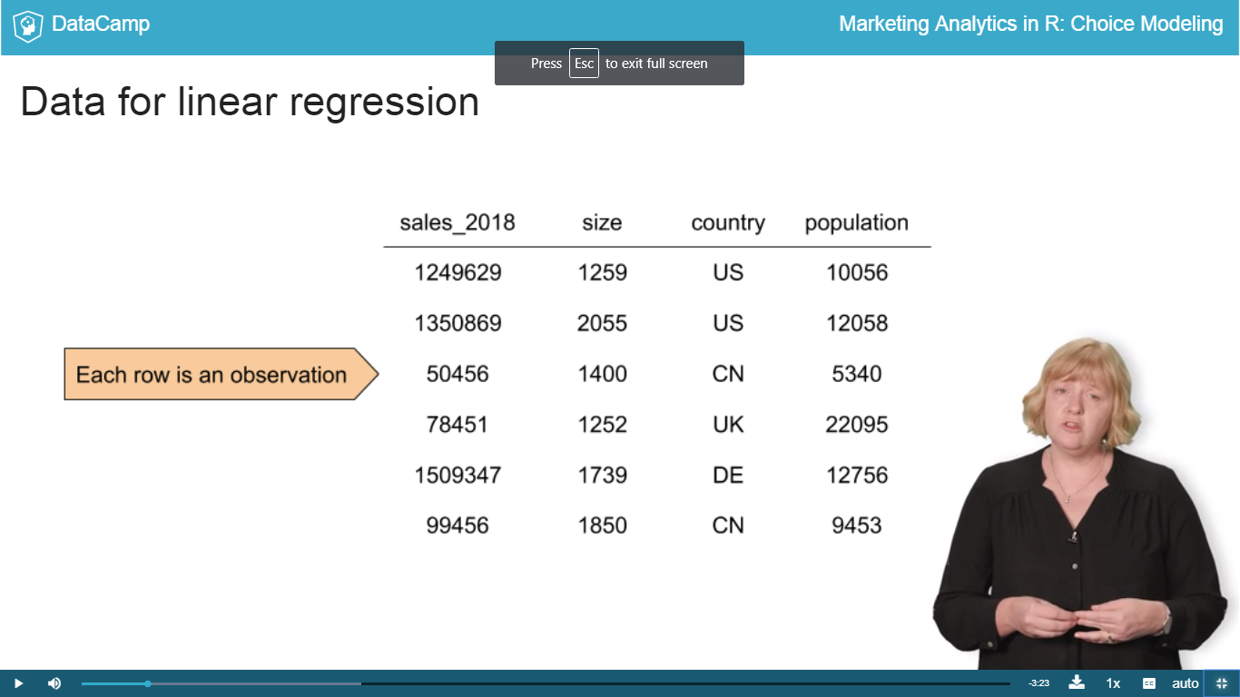

**Data for choice dataset:**

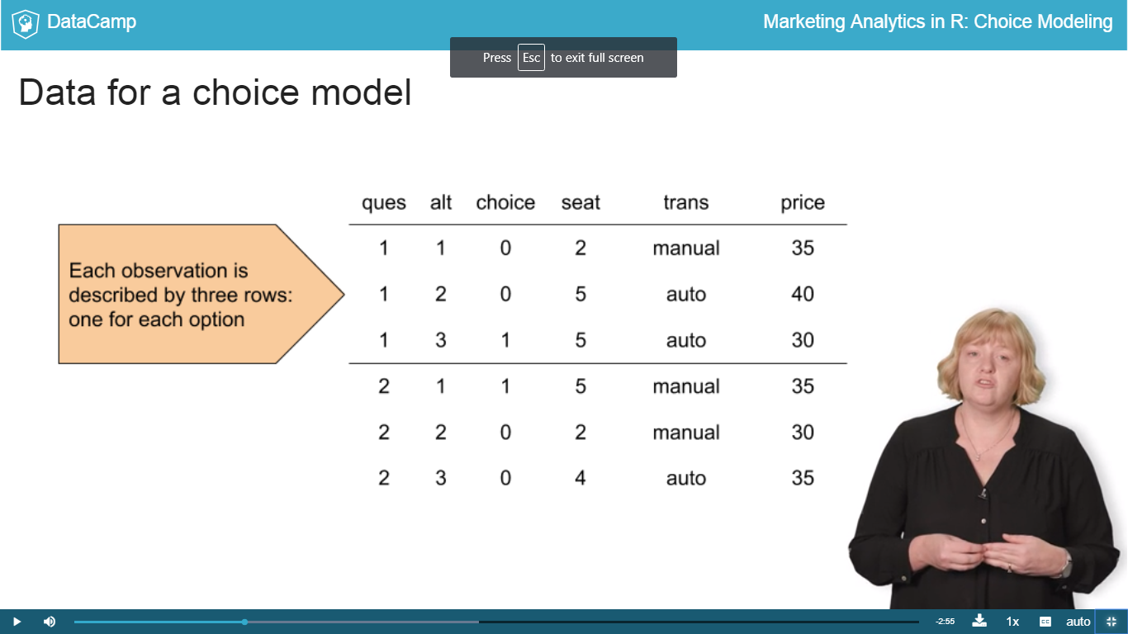

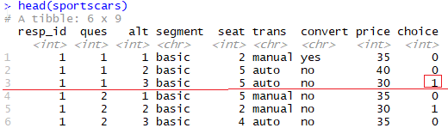

**Long Format:**

